Holbrook
2021 Rain Barrel Program

Save Money, Collect Rain Water, Conserve Energy
with the Great American Rain Barrel

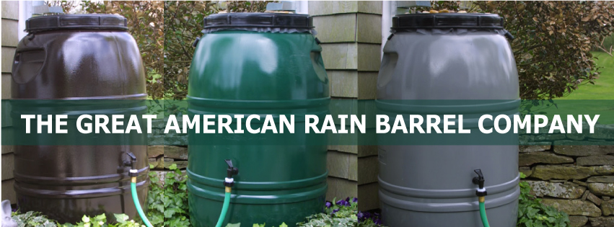
To Order
Contact the Holbrook Public Works Department
njordan@holbrookmassachusetts.us
(781) 767 -1800
Pickup Info
50 North Franklin St
Holbrook MA 02343

While Supplies Last

Did you know that using a rain barrel to collect rainwater conserves energy, reduces storm water runoff and pollution, and may help you save money on your water bill?
The Great American Rain Barrels are heavy duty and come with a choice of two ports to use with either a watering can or a garden hose. Each barrel holds 60 gallons and is available in 3 earth tone colors and unpainted.
Residents are eligible to purchase rain barrels at the discounted rate of $65 for Forest Green, Earth Brown or Nantucket Gray (saving over 40% off the retail price).
Some Facts about the Great American Rain Barrel
• Versatile design, sturdy construction • UV Protected, Food Grade BPA Free
• Each barrel holds 60 gallons • 100% recycled containers
• Manufactured in the USA • 20 years of satisfied customers

